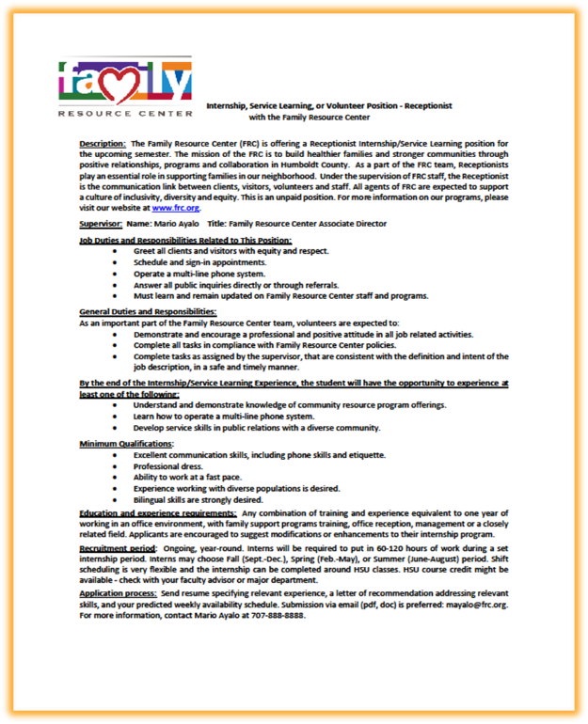
A well-designed position description:
- Ensures positions contribute to your organization's goals and programs.
- Supports a climate of inclusivity, diversity and equity.
- Aids with evaluation efforts to improve services.
- Provides a reflection tool for student learning purposes.

Position descriptions can:
- Simplify aspects of a site supervisor's job: marketing, recruiting, screening, and training students.
- Assist in recruiting students with the right interests, skills, and availability, and matching those individuals successfully with service positions.
- Make clear the student's responsibilities to everyone – student site supervisors, other staff and volunteers - which can remove areas of potential conflict.
- Strengthen the screening process.
- Applicants can screen themselves and apply only for those positions for which they have the interest and skills.
- Facilitate the development of interview questions that match the needs of the organization and the skills needed for each position.

Questions to Consider:
- Will the position clearly support the work of the organizational staff and address a community need?
- Is the position meant to take advantage of certain skills of a student studying from a certain major?
- Is it open to people with varying experience and abilities?
- Will the program provide training?
- How does the site support a climate of inclusivity, equity, and diversity, and how will the student/ position be expected to support these efforts?
- The article here shares tips on how to address systemic challenges by modifying your qualified student search criteria.
- What requirements do students need to meet to begin serve? Background checks, TB tests, and other requirements can take time (and should be figured into the service hours commitment), any may be a financial burden on the student. Consider whether your agency can help mitigate these processes by paying for them, or allowing for exceptions for short-term positions.
- Transportation: consider listing bus routes or other transportation concerns for students needing to travel to and from your site from campus. Students are not allowed to drive for your organization.
- Can the position accommodate a small team of students to accomplish the project goals?

Preparing the Position Description:
- View the service position from the perspective of the student, and highlight aspects of the position that will most appeal to students.
- Display benefits and learning opportunities prominently.
- Determine the length of the project and what best suits an Internship or Service Learning position.
  - Internship experiences are 60+ hours per semester, sometimes over two semesters.
  - Service Learning experiences are 20-30 hours per semester.
- Develop the position within the HSU semester framework, i.e., Fall - September to December; Spring – January to May; Summer – May to August.
- Consider episodic projects that allow different students to come and go from one semester to the next.

